3.3 – Corruption Plagues the Nation

- How did Grant contribute to the loss of confidence in American politicians?

- What were some of the issues relating to government corruption in the United States during this era? What were some of the ways that Americans solved or debated those issues?

- What are possible negative effects of the spoils system, whether in politics, a corporation, or a school environment?

- Cite evidence of the corruption of the spoils system.

- In your opinion, does the spoils system reflect your understanding of American ideals?

- Why do you think that party loyalties were so evenly divided after the end of the Civil War?

- During the Gilded Age, no political party gained power for any length of time. How did this balance affect Congress’s productivity? Why did it affect Congress in this way?

- Summarize the reasons why President Cleveland’s reputation was considered the exception to the rule for presidents from the 1870s through the 1890s.
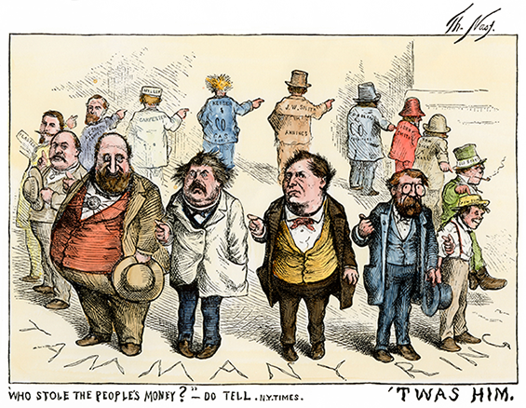
- Who was Boss Tweed, and what does this famous cartoon suggest? Hint: If you are struggling to find the answer, Google the caption and see what you can come up with.

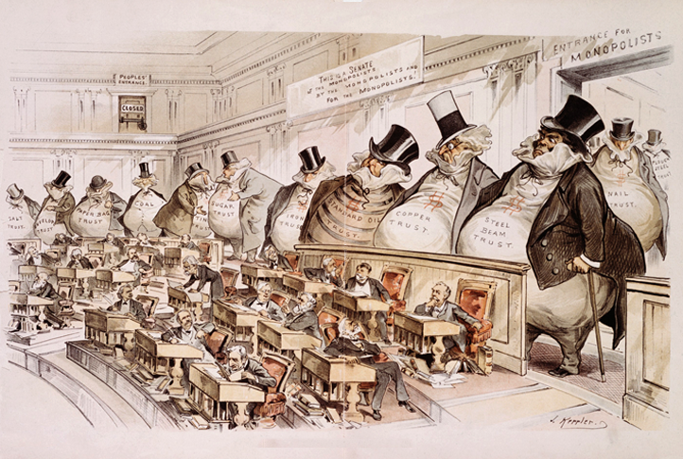
- Joseph Keppler’s famous cartoon shows who he believed was really in charge of the government. Analyze Political Cartoons Why are the businessmen drawn so large compared to the senators? What is Keppler trying to say?

- What were benefits and drawbacks of the spoils system?
  - Benefits:

  - Drawbacks:

- What main problem did civil service reform address?

- Why did public support for civil service reform grow after the assassination of President James Garfield?

- Why did Republicans support a high tariff? Why did Democrats oppose a high tariff? Explain each party’s argument.

- During the Gilded Age, farmers supported the minting of silver because it would increase the money supply and cause inflation. What does farmers’ desire for inflation suggest about the prices they were being paid for their crops? Explain your reasoning.

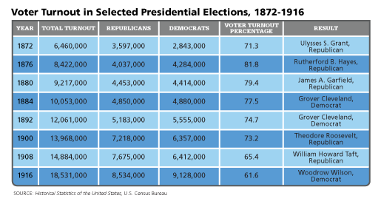
- Is it probable that the presidents of the Gilded Age enjoyed strong popular support for their ideas? Why or why not?

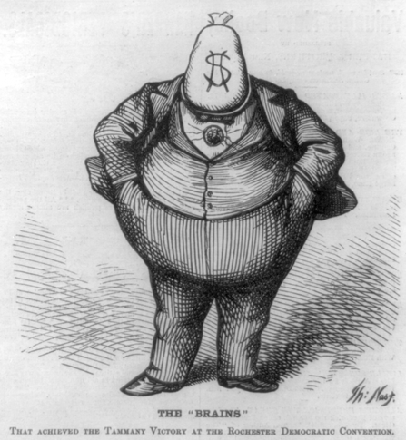
- Cartoonist Thomas Nast used his work to attack government corruption under New York City’s William “Boss” Tweed. Why do you think this cartoon is called “The Brains”?

- What were political machines and what role did they play in American politics?

- What was the importance of the Coinage Act of 1873?

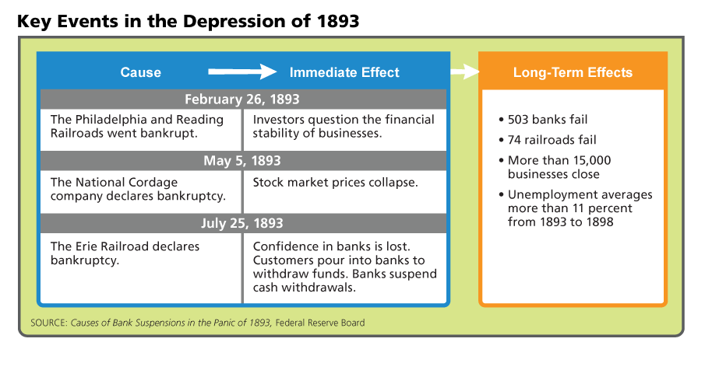
- The causes and effects of the Depression of 1893 and the Panic of 1873 share some common themes. What similarities exist between the two events?

- Why were political cartoons such an effective weapon against corruption?

- Describe the Pendleton Civil Service Act and why it is important.

